***Wooden Led Clock***

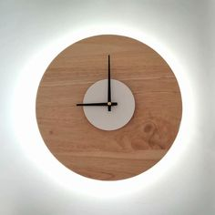

*The wooden bar LED clock is made of high quality plastic with imitation wood grain. There are many different colors and shapes. The parameters on the meter are displayed in digital form. The product can be used simultaneously with a 5V power source (Similar to a phone charger) or an AAA battery that can be easily purchased in the market. Led wooden clocks are very suitable as gifts for classmates, colleagues, especially those who are active and love creativity.*